Special Instructions for 2010 Assistant Grand Sentinels
- First of all I would like to thank all for accepting this position. You’re efforts are much appreciated. Please go through the attached pages thoroughly. They contain all of the information you will need to do your job.
- It is important that the stations numbered 1, 2, 3 & 4 are manned at all times. This is the area by the stage and will need Assistant Grand Sentinels during the entire Grand Session to include introduction of Grand Officers and Installation Ceremony to assist people up and down from the stage.
- If you are unable to be at your station during your designated time, contact one of the Special Assistant Grand Sentinels noted at the top of the Grand Sentinel list. Also, if other questions arise and I am not available, please contact one of the Special Assistants, as they are there to help you.
- You must be present for all opening marches wearing your tuxedo, white shirt and black bow tie. During the day you may wear a business suit or sport coat and slacks, with tie.
- Always assist members and guests in any way to make their visit to Grand Chapter an enjoyable and rewarding experience. Assist and direct members and guests from other Grand Jurisdictions to the proper places designated for them. The Grand Conductress and Associate Grand Conductress will have this information. All Members seeking admission must show a signed Registration Card, which they must have countersigned along the left margin.
- Noise and commotion must be kept to a minimum and if necessary, ask members to refrain from excessive noise. Allow no one to enter or leave or take pictures during opening and closing ceremonies.
- Remember that hats and gloves are not to be worn during the session. The Worthy Grand Matron, under certain circumstances, may grant permission to do so in special cases, such as for medical reasons.
- Consult your programs as to time and place for pictures and practices and be prompt so as not to interfere with other duties and disrupt time schedules for other functions or members. Read your program thoroughly so you are familiar with all scheduled events.
- Your help and assistance in guarding doors and carrying out your many duties is greatly appreciated. I look forward to meeting and working with each of you. If you have any questions, please do not hesitate to contact me at any time during the Grand Session. I hope you have a fun and enjoyable time during Grand Chapter

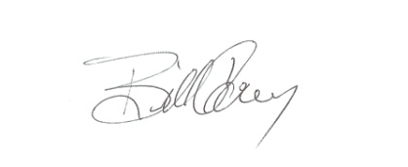
Bill Carey Grand Sentinel

