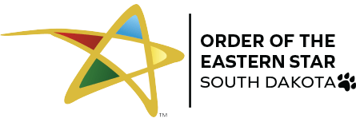
O.E.S. Friendship Across the Borders Weekend
February 11-13 2022
Manatoba~Minnesota~North Dakota ~South Dakota Headquarters Hotel -- Sheraton Sioux Falls
1211 North West Ave
Sioux Falls SD 57104
All Rooms $139.00 plus tax per night
Cut-off date – January 17, 2022

Reservation can also be made on line

Book your group rate for Order of the Eastern Star Feb2022

Or by calling 605-331-0100 ask for the Order of the Eastern Star room block

** Weekend Attire – Casual

Take time to see the sights!
We invite you to plan your free time by taking in some of our attractions such as the Washington Pavillion of Arts and Science, Old Courthouse Museum and Museum of Visual Arts
For more information go to: https://www.experiencesiouxfalls.com/
Gentleman visit the indoor shooting range at The Alliance bring your own weapon or rent one from the Armory. https://www.southdakotaalliance.org/

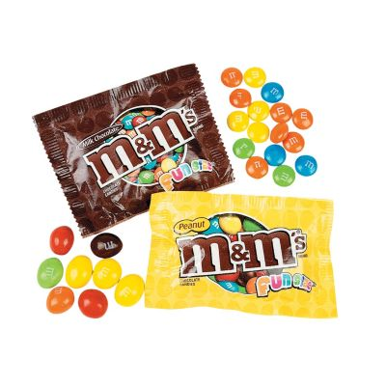

February 11-13 2022
O.E.S. MNMS
FRIENDSHIP WEEKEND HOSTED BY SOUTH DAKOTA
Please fill out one form for each person

Registration (required) $15.00 $

Fri, February 11 – 6:30 pm Dinner in the Fontenelle Ballroom $38.00 $

Sat, February 12 - 8am Continental Breakfast Fontenelle Ballroom…………... $18.00 $
10-4 pm Canvas painting craft………………………….…….$15.00 $____________
6:30 pm. Dinner in the Fontenelle $49.00 $
Sun, February 13 –9:00 am Continental Breakfast Fontenelle Ballroom……….$18.00 $_____________
Worship Service and Send-off

Total Amount enclosed for registration and meals .………..$

*Please note any dietary needs or allergies

NAME

ADDRESS

CITY________________________________________ STATE_____________ ZIP

PHONE__________________________ EMAIL

JURISDICTION____________________________ TITLE

Return this form by January 17, 2022 with your check made payable to Lisa Russell
Lisa Russell Cell phone 605-321-2599
5108 W Manna Grass St Email: lisarusselloes@gmail.com
Sioux Falls SD 57107

